

**Al-Isra University**

**Faculty of IT**

**Department of Computer Science**

**جــامـعـة الإسراء**

**كـليـة تكـنولوجيـا المعلومـات**

**قـســم هندسة البرمجيات**

|  |  |  |
| --- | --- | --- |
| **Department:**  **SE** | **Assignment:**  **#1** | **Date:**  **25/10/2023** |
| **Semester:**  **first** | **Year:**  **2023/2024** | **Instructor**  **Ikhlas AL Mukahel** |
| **Course No.:**  **6034155** | **Course Name:**  **Software Quality Assurance** | **Section:**  **1** |
| **Student No.:**  **AD0039** | **Student Name:**  **فراس سمير رمضان سليم** | **Submission date:**  **28/10/2023** |

|  |  |  |
| --- | --- | --- |
| Question No. | Mark | |
| Max | Score |
| 1 | **5** |  |
| 2 | **5** |  |
| **Total Mark** | **10** |  |

**Activity 1: Software Errors.**

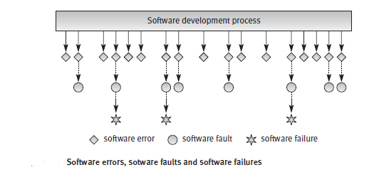

As software errors are the cause of poor software quality, it is important to investigate the causes of these errors in order to prevent them. A software error can be “code error”, a “procedure error”, a “documentation error”, or a “software data error”.

Based on the above, please dicuss the following example:-

**Example 1: The “Pharm-Plus” software package**

**“Pharm-Plus”**, a software package developed for the operations required of a pharmacy chain, included several software faults, such as the following:

(a) The chain introduced a software requirement to avoid the current sale of goods to customers whose total debts will exceed $200 upon completion of the current sale. Unfortunately, the programmer erroneously put the limit at $500, a clear software fault. However, a software failure never occurred as the chain’s pharmacies do not offer credit to their customers, that is, sales are cash sales or credit card sales.

🡺 This can be categorized as a "code error." The programmer mistakenly set the limit at $500 when it should have been $200, which is a clear coding error.

(b) Another requirement introduced was the identification of “super customers”.These were defined as those customers of the pharmacy who made a purchase at least once a month, the average value of that purchase made in the last M months (e.g., 12 months) being more than N times (e.g., five times) the value of the average customer’s purchase at the pharmacy. It was required that once “super customers” reached the cashier, they would be automatically identified by the cash register. (The customers could then be treated accordingly, by receiving a special discount or gift, for example.) The software fault (caused by the system analyst) was that “super customers” could be identified solely by the value of their current purchase. In other words, customers whose regular purchases consisted of only one or two low-cost items could mistakenly be identified as “super customers”.

🡺 This error can be classified as a "procedure error." The system analyst introduced a requirement to identify "super customers" based on specific criteria, but the procedure for identifying them was flawed. Customers who made small, frequent purchases could be erroneously identified as "super customers." This is a procedural error in the design and implementation of the software's functionality.

**Classification of the causes of software errors**

**Q2: Classify this errors to The causes of software errors which can be further classified as follows according to the stages of the software development process in which they occur.**

1. Absence of vital requirements.

🡺Faulty requirements definition

1. Due to time or budget pressures, the developer decides to omit part of therequired functions in an attempt to cope with these pressures.

🡺 Deliberate deviations from software requirements

1. Definitions that represent software requirements by means of erroneous algorithms.

🡺 Logical design errors

1. Incomplete test plans leave untreated portions of the software or the application functions and states of the system.

🡺Shortcomings of the testing process

1. Failures to document and report detected errors and faults.

🡺 Documentation errors

1. Omission of software functions

🡺 Deliberate deviations from software requirements"

1. Erroneous definition of boundary conditions

🡺 Faulty requirements definition

1. Individuals replacing the “non-complying” team member.

🡺 Client-developer communication failures

1. Process definitions that contain sequencing errors

🡺 Faulty requirements definition

1. Misunderstanding of the client’s responses to the design problems

🡺 Client-developer communication failures

**GOOD LUCK ☺**